About: Bengali Department
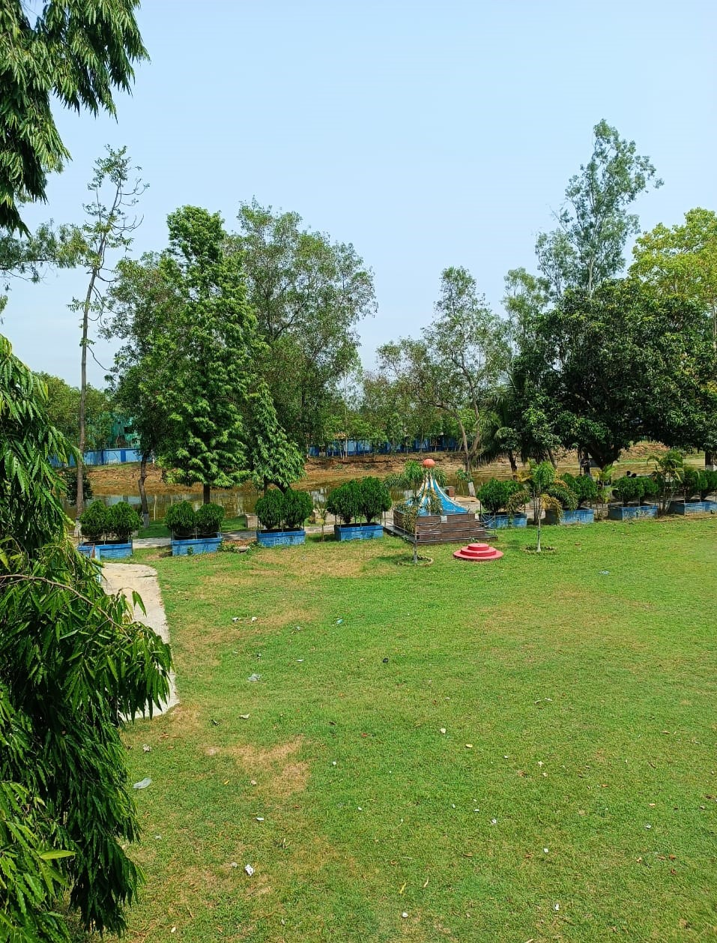 | The Department of Bengali of Samsi College was established in the year of 2002 on 14th June. In the department undergraduate course is offered in the subject Bengali. The annual system was followed until the academic year of 2017- 2018. From the academic year 2018-2019 CBCS system has been regulated. The Department has 1 associate professor,1 assistant professor and 3 SACTs . Along with that we have 2 research fellows who are pursuing there research over here. The department has conducted many national and international level seminars.Apart from that our department motivates and inspires the students to come up with their creative as well as innovative writings.2 books have been already published from our department. Our alumni students also participate in such avtivities who have succeessfully published one book.We conduct many such extension activities like -  1.Little magazine  2.Anti-nicotine campaign  3.hosting blood donation camps  4.wall magazine  Our students after successful completion of degree have succeeded in achieving higher degrees from renowned institutions. The former students of our departments have also successfully achieved teaching jobs in schools and colleges. Our goal is to provide moral character building, holistic and value-based education.

